|  |  |  |
| --- | --- | --- |
| **CL-1004 Object Oriented Programming** | **LAB - 02**  **C++ data types, functions, struct revisited** | |
| **NATIONAL UNIVERSITY OF COMPUTER AND EMERGING SCIENCES**  **Spring 2023** | |  |

While writing a program in any language, you need to use various variables to store various information. Variables are nothing but reserved memory locations to store values. This means that when you create a variable you reserve some space in memory.

You may like to store information of various data types like character, wide character, integer, floating point, double floating point, Boolean etc. Based on the data type of a variable, the operating system allocates memory and decides what can be stored in the reserved memory.

## Primitive Built-in Types

C++ offers the programmer a rich assortment of built-in as well as user defined data types. Following table lists down seven basic C++ data types −

|  |  |
| --- | --- |
| **Type** | **Keyword** |
| Boolean | bool |
| Character | char |
| Integer | int |
| Floating point | float |
| Double floating point | double |
| Valueless | void |
| Wide character | wchar_t |

Several of the basic types can be modified using one or more of these type modifiers

* signed
* unsigned
* short
* long

The following table shows the variable type, how much memory it takes to store the value in memory, and what is maximum and minimum value which can be stored in such type of variables.

|  |  |  |
| --- | --- | --- |
| **Type** | **Typical Bit Width** | **Typical Range** |
| char | 1byte | -127 to 127 or 0 to 255 |
| unsigned char | 1byte | 0 to 255 |
| signed char | 1byte | -127 to 127 |
| int | 4bytes | -2147483648 to 2147483647 |
| unsigned int | 4bytes | 0 to 4294967295 |
| signed int | 4bytes | -2147483648 to 2147483647 |
| short int | 2bytes | -32768 to 32767 |
| unsigned short int | 2bytes | 0 to 65,535 |
| signed short int | 2bytes | -32768 to 32767 |
| long int | 8bytes | -9223372036854775808 to 9223372036854775807 |
| signed long int | 8bytes | same as long int |
| unsigned long int | 8bytes | 0 to 18446744073709551615 |
| long long int | 8bytes | -(2^63) to (2^63)-1 |
| unsigned long long int | 8bytes | 0 to 18,446,744,073,709,551,615 |
| float | 4bytes |  |
| double | 8bytes |  |
| long double | 12bytes |  |
| wchar_t | 2 or 4 bytes | 1 wide character |

The size of variables might be different from those shown in the above table, depending on the compiler and the computer you are using.

Following is the example, which will produce correct size of various data types on your computer.

#include <iostream>

using namespace std;

int main() {

cout << "Size of char : " << sizeof(char) << endl;

cout << "Size of int : " << sizeof(int) << endl;

cout << "Size of short int : " << sizeof(short int) << endl;

cout << "Size of long int : " << sizeof(long int) << endl;

cout << "Size of float : " << sizeof(float) << endl;

cout << "Size of double : " << sizeof(double) << endl;

cout << "Size of wchar_t : " << sizeof(wchar_t) << endl;

return 0;

}

This example uses **endl**, which inserts a new-line character after every line and << operator is being used to pass multiple values out to the screen. We are also using **sizeof()** operator to get size of various data types.

When the above code is compiled and executed, it produces the following result which can vary from machine to machine −

Size of char : 1

Size of int : 4

Size of short int : 2

Size of long int : 4

Size of float : 4

Size of double : 8

Size of wchar_t : 4

Following is another example:

#include <iostream>

#include <limits>

using namespace std;

int main() {

std::cout << "Int Min " << std::numeric_limits<int>::min() << endl;

std::cout << "Int Max " << std::numeric_limits<int>::max() << endl;

std::cout << "Unsigned Int Min " << std::numeric_limits<unsigned int>::min() << endl;

std::cout << "Unsigned Int Max " << std::numeric_limits<unsigned int>::max() << endl;

std::cout << "Long Int Min " << std::numeric_limits<long int>::min() << endl;

std::cout << "Long Int Max " << std::numeric_limits<long int>::max() << endl;

std::cout << "Unsigned Long Int Min " << std::numeric_limits<unsigned long int>::min() <<endl;

std::cout << "Unsigned Long Int Max " << std::numeric_limits<unsigned long int>::max() << endl;

}

AD

## typedef Declarations

You can create a new name for an existing type using **typedef**. Following is the simple syntax to define a new type using typedef −

typedef type newname;

For example, the following tells the compiler that feet is another name for int −

typedef int feet;

Now, the following declaration is perfectly legal and creates an integer variable called distance −

feet distance;

C++ Functions

A function is a block of code that performs a specific task.

Suppose we need to create a program to create a circle and color it. We can create two functions to solve this problem:

1. a function to draw the circle.
2. a function to color the circle.

Dividing a complex problem into smaller chunks makes our program easy to understand and reusable. There are two types of function:

1. Standard Library Functions: Predefined in C++
2. User-defined Function: Created by user

## C++ User-defined Function

C++ allows the programmer to define their own function.

A user-defined function groups code to perform a specific task and that group of code is given a name (identifier).

When the function is invoked from any part of the program, it all executes the codes defined in the body of the function.

### C++ Function Declaration

The syntax to declare a function is:

returnType functionName (parameter1, parameter2,...) {

// function body

}

Here's an example of a function declaration.

// function declaration

void greet() {

cout << "Hello World";

}

Here, the name of the function is greet() the return type of the function is void the empty parentheses mean it doesn't have any parameters the function body is written inside {}

**Note:** We will learn about returnType and parameters later in this tutorial.

### Calling a Function

In the above program, we have declared a function named greet(). To use the greet() function, we need to call it.

Here's how we can call the above greet() function.

int main() {

// calling a function

greet();

}

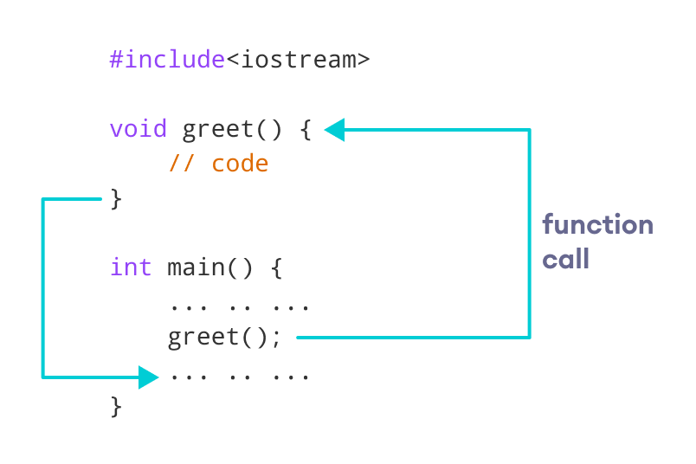

How Function works in C++

### Example 1: Display a Text

#include <iostream>

using namespace std;

// declaring a function

void greet() {

cout << "Hello there!";

}

int main() {

// calling the function

greet();

return 0;

}

[Run Code](https://www.programiz.com/cpp-programming/online-compiler)

**Output**

Hello there!

### Function Parameters

As mentioned above, a function can be declared with parameters (arguments). A parameter is a value that is passed when declaring a function.

For example, let us consider the function below:

void printNum(int num) {

cout << num;

}

Here, the int variable num is the function parameter.

We pass a value to the function parameter while calling the function.

int main() {

int n = 7;

// calling the function

// n is passed to the function as argument

printNum(n);

return 0;

}

### Example 2: Function with Parameters

// program to print a text

#include <iostream>

using namespace std;

// display a number

void displayNum(int n1, float n2) {

cout << "The int number is " << n1;

cout << "The double number is " << n2;

}

int main() {

int num1 = 5;

double num2 = 5.5;

// calling the function

displayNum(num1, num2);

return 0;

}

**Output**

The int number is 5

The double number is 5.5

In the above program, we have used a function that has one int parameter and one double parameter.

We then pass num1 and num2 as arguments. These values are stored by the function parameters n1 and n2 respectively.

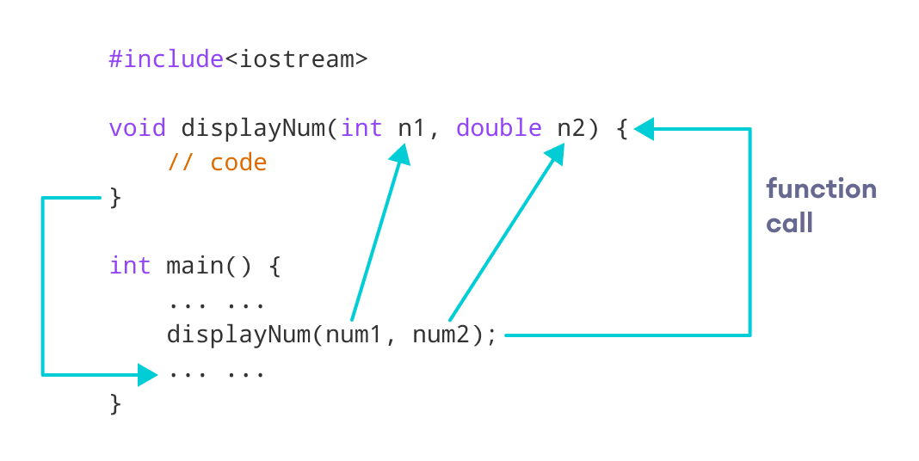

**Note:** The type of the arguments passed while calling the function must match with the corresponding parameters defined in the function declaration.

### Return Statement

In the above programs, we have used void in the function declaration. For example,

void displayNumber() {

// code

}

This means the function is not returning any value.

It's also possible to return a value from a function. For this, we need to specify the returnType of the function during function declaration.

Then, the return statement can be used to return a value from a function.

For example,

int add (int a, int b) {

return (a + b);

}

Here, we have the data type int instead of void. This means that the function returns an int value.

The code return (a + b); returns the sum of the two parameters as the function value.

The return statement denotes that the function has ended. Any code after return inside the function is not executed.

### Example 3: Add Two Numbers

// program to add two numbers using a function

#include <iostream>

using namespace std;

// declaring a function

int add(int a, int b) {

return (a + b);

}

int main() {

int sum;

// calling the function and storing

// the returned value in sum

sum = add(100, 78);

cout << "100 + 78 = " << sum << endl;

return 0;

}

[Run Code](https://www.programiz.com/cpp-programming/online-compiler)

**Output**

100 + 78 = 178

In the above program, the add() function is used to find the sum of two numbers.

We pass two int literals 100 and 78 while calling the function.

We store the returned value of the function in the variable sum, and then we print it.

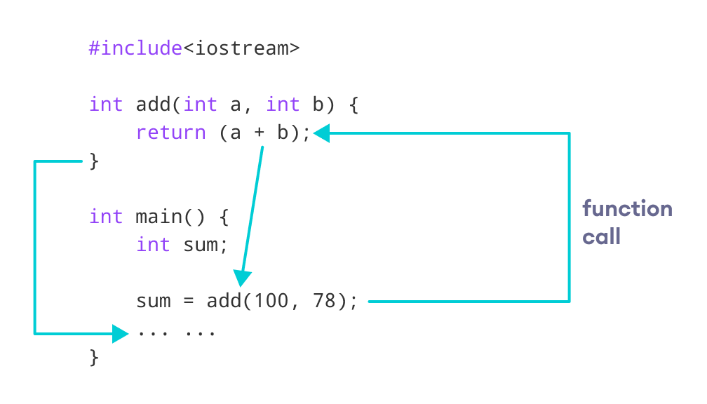

Notice that sum is a variable of int type. This is because the return value of add() is of int type.

### Function Prototype

In C++, the code of function declaration should be before the function call. However, if we want to define a function after the function call, we need to use the function prototype. For example,

// function prototype

void add(int, int);

int main() {

// calling the function before declaration.

add(5, 3);

return 0;

}

// function definition

void add(int a, int b) {

cout << (a + b);

}

In the above code, the function prototype is:

void add(int, int);

This provides the compiler with information about the function name and its parameters. That's why we can use the code to call a function before the function has been defined.

The syntax of a function prototype is:

returnType functionName(dataType1, dataType2, ...);

### Example 4: C++ Function Prototype

// using function definition after main() function

// function prototype is declared before main()

#include <iostream>

using namespace std;

// function prototype

int add(int, int);

int main() {

int sum;

// calling the function and storing

// the returned value in sum

sum = add(100, 78);

cout << "100 + 78 = " << sum << endl;

return 0;

}

// function definition

int add(int a, int b) {

return (a + b);

}

**Output**

100 + 78 = 178

The above program is nearly identical to **Example 3**. The only difference is that here, the function is defined **after**the function call.

That's why we have used a function prototype in this example.

### Benefits of Using User-Defined Functions

Functions make the code reusable. We can declare them once and use them multiple times.

Functions make the program easier as each small task is divided into a function.

Functions increase readability.

## C++ Library Functions

Library functions are the built-in functions in C++ programming.

Programmers can use library functions by invoking the functions directly; they don't need to write the functions themselves.

Some common library functions in C++ are sqrt(), abs(), isdigit(), etc.

In order to use library functions, we usually need to include the header file in which these library functions are defined.

For instance, in order to use mathematical functions such as sqrt() and abs(), we need to include the header file cmath.

### Example 5: C++ Program to Find the Square Root of a Number

#include <iostream>

#include <cmath>

using namespace std;

int main() {

double number, squareRoot;

number = 25.0;

// sqrt() is a library function to calculate the square root

squareRoot = sqrt(number);

cout << "Square root of " << number << " = " << squareRoot;

return 0;

}

[Run Code](https://www.programiz.com/cpp-programming/online-compiler)

**Output**

Square root of 25 = 5

In this program, the sqrt() library function is used to calculate the square root of a number.

The function declaration of sqrt() is defined in the cmath header file. That's why we need to use the code #include <cmath> to use the sqrt() function.

## Pass by value

#include <iostream>

using namespace std;

void update (int x){

x++;

}

int main(){

int val = 10;

cout << "before change : "<< val << endl;

update(val);

cout << "after change : "<< val << endl;

return 0;}

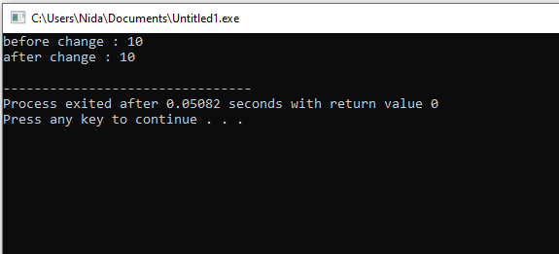

## Pass by Address

#include <iostream>

using namespace std;

void update (int* x){

*x= 100;

}

int main(){

int val = 10;

cout << "before change : "<< val << endl;

update(&val);

cout << "after change : "<< val << endl;

return 0;

}

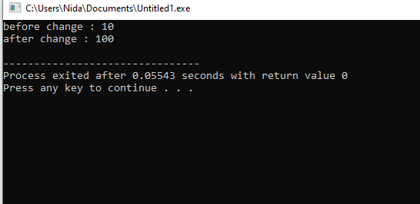

## Pass by reference

#include <iostream>

using namespace std;

void update (int& x){

x++;

}

int main(){

int val = 10;

cout << "before change : "<< val << endl;

update(val);

cout << "after change : "<< val << endl;

return 0;

}

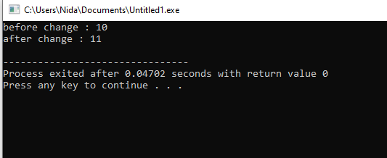

C++ Recursion

A [function](https://www.programiz.com/cpp-programming/function) that calls itself is known as a recursive function. And this technique is known as recursion.

## Working of Recursion in C++

void recurse()

{

... .. ...

recurse();

... .. ...

}

int main()

{

... .. ...

recurse();

... .. ...

}

The figure below shows how recursion works by calling itself over and over again.

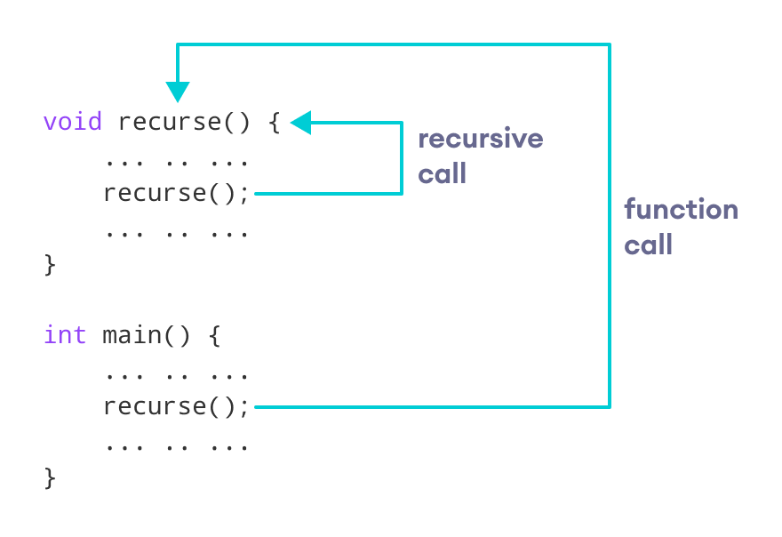

The recursion continues until some condition is met.

To prevent infinite recursion, if...else statement (or similar approach) can be used where one branch makes the recursive call and the other doesn't.

## Example 1: Factorial of a Number Using Recursion

#include <iostream>

using namespace std;

int Fact (int x){

if(x == 0 || x==1){

return 1;

}

return x*Fact(x-1);

}

int main(){

cout << "Factorial is : "<< Fact(5) ;

return 0;

}

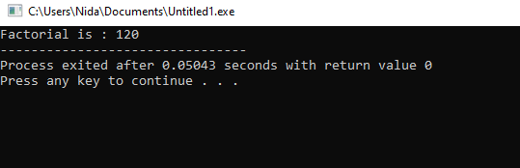

// Factorial of n = 1*2*3*...*n

#include <iostream>

using namespace std;

int factorial(int);

int main() {

int n, result;

cout << "Enter a non-negative number: ";

cin >> n;

result = factorial(n);

cout << "Factorial of " << n << " = " << result;

return 0;

}

int factorial(int n) {

if (n > 1) {

return n * factorial(n - 1);

} else {

return 1;

}

}

**Output**

Enter a non-negative number: 4

Factorial of 4 = 24

### Working of Factorial Program

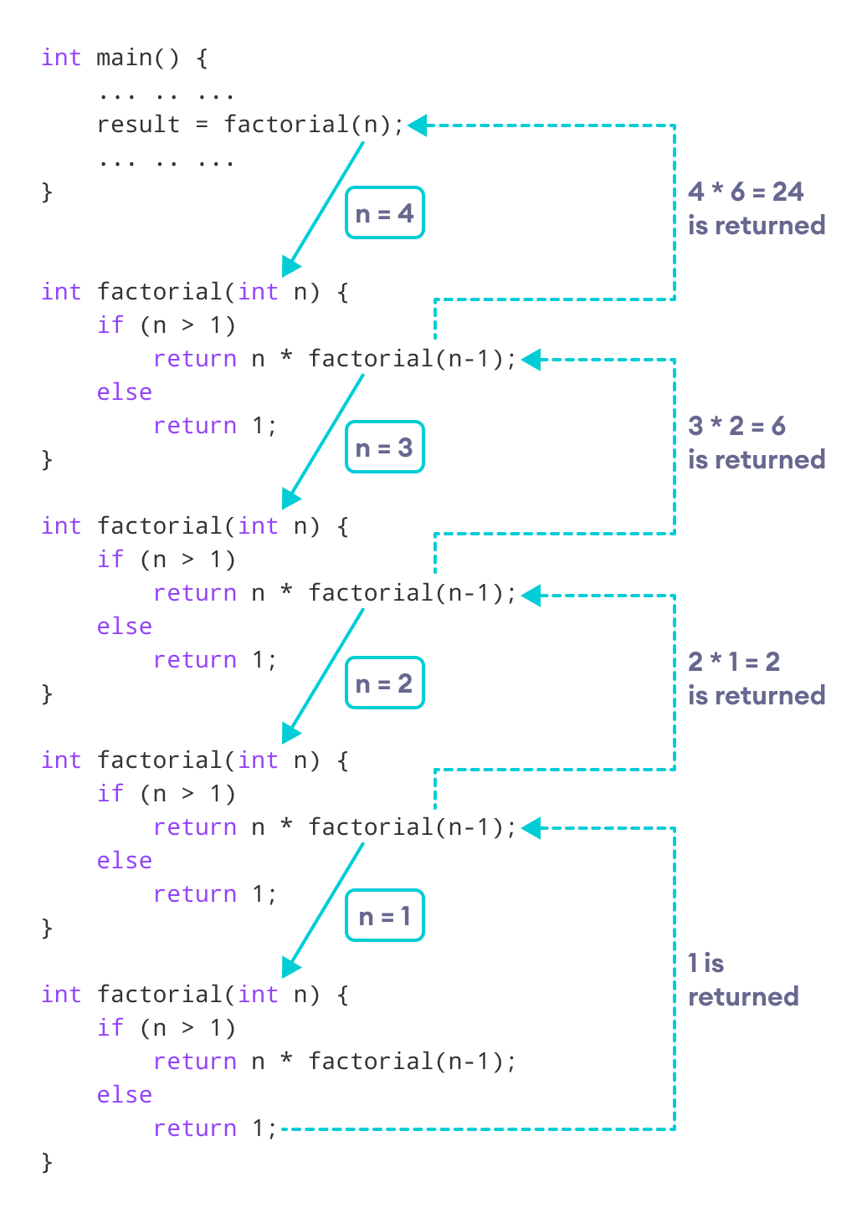

As we can see, the factorial() function is calling itself. However, during each call, we have decreased the value of n by 1. When n is less than 1, the factorial() function ultimately returns the output.

### Advantages of C++ Recursion

1. It makes our code shorter and cleaner.
2. Recursion is required in problems concerning data structures and advanced algorithms, such as Graph and Tree Traversal.

### Disadvantages of C++ Recursion

1. It takes a lot of stack space compared to an iterative program.
2. It uses more processor time.
3. It can be more difficult to debug compared to an equivalent iterative program.

## C++ Structures

Structure is a collection of variables of different data types under a single name. It is similar to a class in that, both holds a collection of data of different data types.

For example: You want to store some information about a person: his/her name, citizenship number and salary. You can easily create different variables name, citNo, salary to store this information separately.

However, in the future, you would want to store information about multiple people. Now, you'd need to create different variables for each information per person: name1, citNo1, salary1, name2, citNo2, salary2.

You can easily visualize how big and messy the code would look. Also, since no relation between the variables (information) would exist, it's going to be a daunting task. A better approach will be to have a collection of all related information under a single name Person, and use it for every person. Now, the code looks much cleaner, readable and efficient as well. This collection of all related information under a single name Person is a structure.

**How to declare a structure in C++ programming?**

The struct keyword defines a structure type followed by an identifier (name of the structure). Then inside the curly braces, you can declare one or more members (declare variables inside curly braces) of that structure. For example:

**struct** Person

{

char name[50];

int age;

float salary;

};

Here a structure person is defined which has three members: name, age and salary.

When a structure is created, no memory is allocated. The structure definition is only the blueprint for the creating of variables. You can imagine it as a datatype. When you define an integer as below:

int foo;

The int specifies that, variable foo can hold integer element only. Similarly, structure definition only specifies that, what property a structure variable holds when it is defined.

Note: Remember to end the declaration with a semicolon (;)

**How to define a structure variable?**

Once you declare a structure person as above. You can define a structure variable as:

Person bill;

Here, a structure variable bill is defined which is of type structure Person. When structure variable is defined, only then the required memory is allocated by the compiler. Considering you have either 32-bit or 64-bit system, the memory of float is 4 bytes, memory of int is 4 bytes and memory of char is 1 byte. Hence, 58 bytes of memory is allocated for structure variable bill.

**How to access members of a structure?**

The members of structure variable is accessed using a dot (.) operator. Suppose, you want to access age of structure variable bill and assign it 50 to it. You can perform this task by using following code below:

bill.age = 50

**Example: C++ Structure**

#include <iostream>

using namespace std;

struct Person

{

char name[50];

int age;

float salary;

};

int main()

{

Person p1;

cout << "Enter Full name: ";

cin.get(p1.name, 50);

cout << "Enter age: ";

cin >> p1.age;

cout << "Enter salary: ";

cin >> p1.salary;

cout << "\nDisplaying Information." << endl;

cout << "Name: " << p1.name << endl;

cout <<"Age: " << p1.age << endl;

cout << "Salary: " << p1.salary;

return 0;

}

**Output**

Enter Full name: Magdalena Dankova

Enter age: 27

Enter salary: 1024.4

Displaying Information.

Name: Magdalena Dankova

Age: 27

Salary: 1024.4

Here a structure Person is declared which has three members name, age and salary. Inside main() function, a structure variable p1 is defined. Then, the user is asked to enter information and data entered by user is displayed.

Exercises:

Task 1. Write Program to Find the Factorial of a Number Using Recursion

Input: Enter Number for its factorial = 5

Output: Factorial of Number 5 is = 120

Task 2. **a) Write a recursive function to find the sum of n natural numbers where n >= 1**

1. **Write a countDown(int number) method in Java using Recursion which prints countdown till zero to console, like count(3) should print 3 2 1 0.**
2. **Write a Java program to calculate the power of a number like power(int number, int power) like power(2, 3) should return 8?**

Task 3. Create a Function that takes two variables and swaps the elements between the variables using reference variable

Task 4. Let us work on the menu of a library. Create a structure containing book information like

accession number, name of author, book title and flag to know whether book is issued or not.

Create a menu in which the following can be done.

1 - Display book information

2 - Add a new book

3 - Display all the books in the library of a particular author

4 - Display the number of books of a particular title

5 - Display the total number of books in the library

6 - Issue a book

(If we issue a book, then its number gets decreased by 1 and if we add a book, its number gets

increased by 1)

Task 5. You need to implement the the following 2 struct.

struct Student{}; struct Register{}; Student contains attribute StudentId, FirstName, LastName, cellno, email.

Register contains attribute CourseId, CourseName. Now you need to inherit the Register struct in Student struct. It means that student struct holds the variable of Register struct variable. After that you need to take input for 5 students and then print them

[Hint: Declare array of struct Student std[5]; for 5 students ]

Task 6. Ankush challenges Ankit to complete his code which implements the functionality of checking if the first and last name of a student is an anagram of each other or not.

An anagram of a string is another string that contains same characters, only the order of characters can be different. For example, “act” and “tac” are anagram of each other. Invest your time to study the locked code and complete it accordingly.

**Input:**  
The first line contains the number of test cases, each test case consists of one line input containing 2 space separated strings representing the first and last name of the student.

**Output:**  
For each test case **T**, the output should consist of a single line - **ANAGRAM**or **NOT ANAGRAM** depending upon if the 2 given strings are anagram of each other or not.

**Example:  
Input:**  
2  
rahul garg   
ankit kitan

**Output:**  
NOT ANAGRAM  
ANAGRAM

Task 7.

Consider there are two structures Employee (depended structure) and another structure called Organisation(Outer structure). The structure Organization has the data members like organisation_name,organisation_number. The Employee structure is nested inside the structure Organization and it has the data members like employee_id, name, salary.

org.emp.employee_id;

org.emp.name;

org.emp.salary;

org.organisation_name;

org.organisation_number;

Here, org is the structure variable of the outer structure Organisation and emp is the structure variable of the inner structure Employee.

Output the following data using above structure

The size of structure organisation : 123

Organisation Name : NU-Fast

Organisation Number : NUFAST123ABC

Employee id : 127

Employee name : Linus Sebastian

Employee Salary : 400000